**Power BI- Lecture 2**

Power BI Basic Power Charts

**“If You keep asking questions to your data set many many questions I t will tell Details and insights”**

1. **What is power BI: -**
2. **Types of Data connection power BI: -**
3. **Text Functions Using Power BI: -**

**Data Analysis Expressions (DAX) is a library of functions and operators that can be combined to build formulas and expressions in Power BI, Analysis Services, and Power Pivot in Excel data models.**

**DAX Text Functions: - (** [**https://learn.microsoft.com/en-us/dax/text-functions-dax**](https://learn.microsoft.com/en-us/dax/text-functions-dax) **)**

| **Function** | **Description** |
| --- | --- |
| [COMBINEVALUES](https://learn.microsoft.com/en-us/dax/combinevalues-function-dax) | Joins two or more text strings into one text string. |
| [CONCATENATE](https://learn.microsoft.com/en-us/dax/concatenate-function-dax) | Joins two text strings into one text string. |
| [CONCATENATEX](https://learn.microsoft.com/en-us/dax/concatenatex-function-dax) | Concatenates the result of an expression evaluated for each row in a table. |
| [EXACT](https://learn.microsoft.com/en-us/dax/exact-function-dax) | Compares two text strings and returns TRUE if they are exactly the same, FALSE otherwise. |
| [FIND](https://learn.microsoft.com/en-us/dax/find-function-dax) | Returns the starting position of one text string within another text string. |
| [FIXED](https://learn.microsoft.com/en-us/dax/fixed-function-dax) | Rounds a number to the specified number of decimals and returns the result as text. |
| [FORMAT](https://learn.microsoft.com/en-us/dax/format-function-dax) | Converts a value to text according to the specified format. |
| [LEFT](https://learn.microsoft.com/en-us/dax/left-function-dax) | Returns the specified number of characters from the start of a text string. |
| [LEN](https://learn.microsoft.com/en-us/dax/len-function-dax) | Returns the number of characters in a text string. |
| [LOWER](https://learn.microsoft.com/en-us/dax/lower-function-dax) | Converts all letters in a text string to lowercase. |
| [MID](https://learn.microsoft.com/en-us/dax/mid-function-dax) | Returns a string of characters from the middle of a text string, given a starting position and length. |
| [REPLACE](https://learn.microsoft.com/en-us/dax/replace-function-dax) | REPLACE replaces part of a text string, based on the number of characters you specify, with a different text string. |
| [REPT](https://learn.microsoft.com/en-us/dax/rept-function-dax) | Repeats text a given number of times. |
| [RIGHT](https://learn.microsoft.com/en-us/dax/right-function-dax) | RIGHT returns the last character or characters in a text string, based on the number of characters you specify. |
| [SEARCH](https://learn.microsoft.com/en-us/dax/search-function-dax) | Returns the number of the character at which a specific character or text string is first found, reading left to right. |
| [SUBSTITUTE](https://learn.microsoft.com/en-us/dax/substitute-function-dax) | Replaces existing text with new text in a text string. |
| [TRIM](https://learn.microsoft.com/en-us/dax/trim-function-dax) | Removes all spaces from text except for single spaces between words. |
| [UNICHAR](https://learn.microsoft.com/en-us/dax/unichar-function-dax) | Returns the Unicode character referenced by the numeric value. |
| [UNICODE](https://learn.microsoft.com/en-us/dax/unicode-function-dax) | Returns the numeric code corresponding to the first character of the text string. |
| [UPPER](https://learn.microsoft.com/en-us/dax/upper-function-dax) | Converts a text string to all uppercase letters. |
| [VALUE](https://learn.microsoft.com/en-us/dax/value-function-dax) | Converts a text string that represents a number to a number. |

**For example: -**

**1-LEN: -** (2 – Customer Data CSV)

New column from examples

**2-CONCATENATE: -** (2 – Customer Data CSV)

& to concatenate

**3-LEFT: -** (2 – Customer Data CSV)

New column from examples

1. **Format Tools in Power BI: - (Data format)**

**1- Text to Num: -** (2 – Customer Data CSV)

* Annual Income Column into whole number
* Remove $ using replace $ with “ ”
* Then Convert

**2- Text to Date Format: -** (2 – Customer Data CSV)

* Add column from examples 5/22/2023 to 22/5/2023
* Then delete original column and
* do the rest

1. **Create Tables in Power BI: - (Data format)**

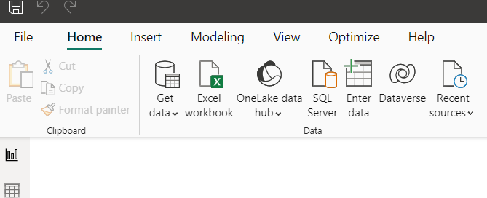

1. **Dealing With Date and Time: -**
2. **Conditional Formatting: -**

* **Condition (if else)**

1. **Merge and Appending: -**

* **Load to Tables from different CSV**
* **Select common columns from both the tables**
* **And hit Enter**



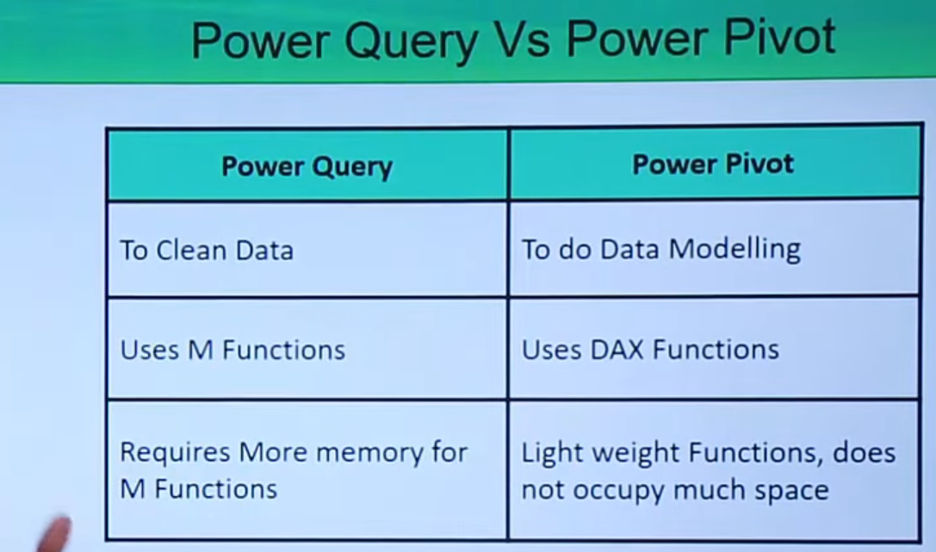

**1- Text to Num: -** (2 – Customer Data CSV)

**Power BI Charts: -**

**1-Column Chart: -** (1- Sales Data July CSV)

**2-Stacked Chart: -** (1- Sales Data July CSV)

**3-Pie Chart: -**(1- Sales Data July CSV)

**4-Funnel Chart: -**(1- Sales Data July)

**5-Ribbon Chart: -**(1- Sales Data July)